DATA MANAGEMENT SYSTEM

2 DMS PROJECT PHASE – I SPECIFICATIONS
2.1 Graphical User Interface

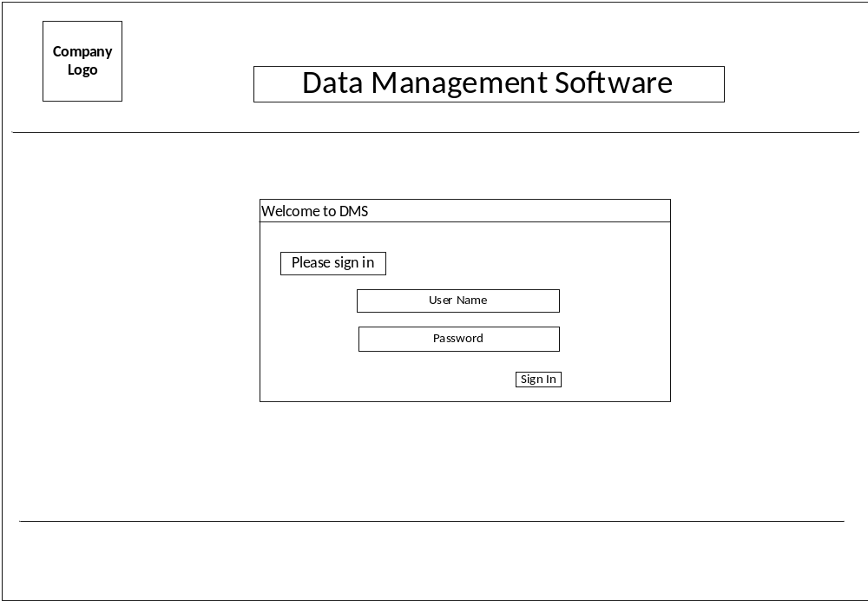
Figure 1: Page – 1 wireframe login page
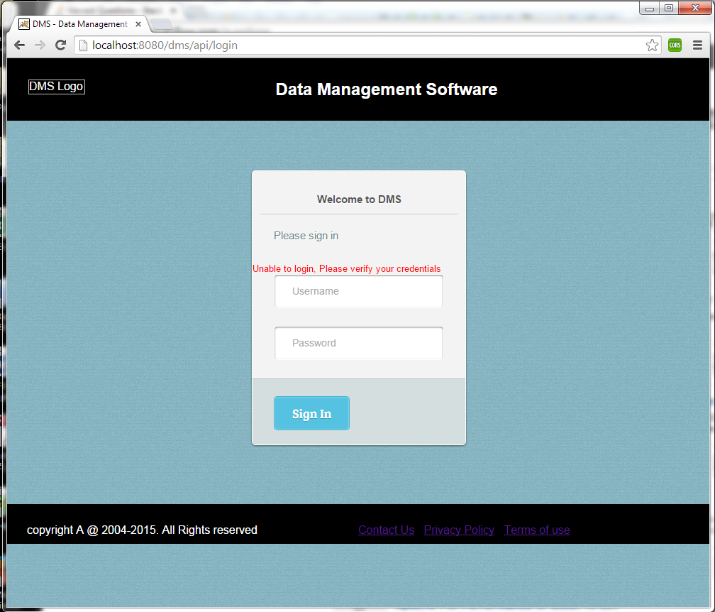
Figure 2: Page – 1 actual login page on the browser

This login page (no changes required), which takes the user name and password will then verifies the data with database and authenticates if matches.

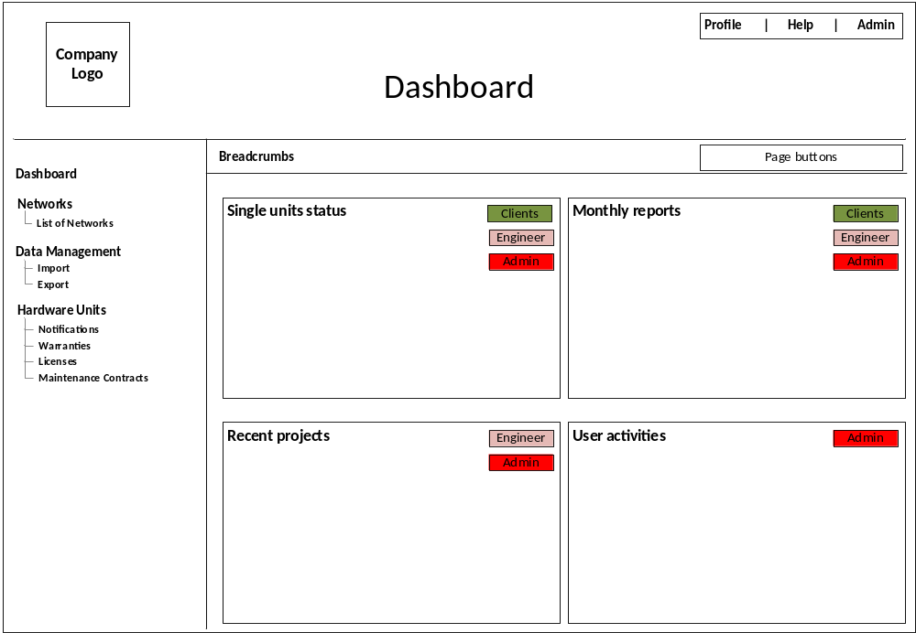
Figure 3: Page – 2 wireframe dashboard page

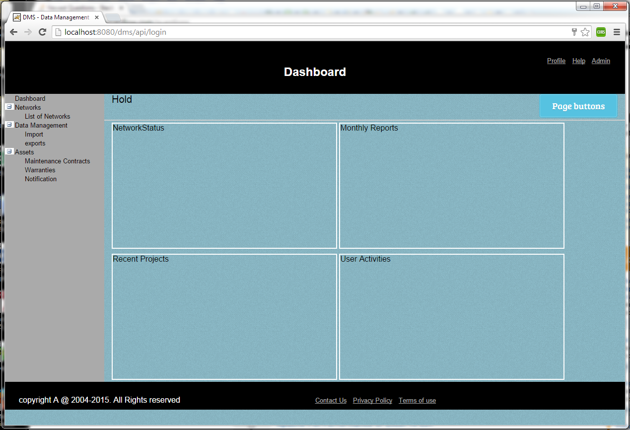
Figure 4: Page – 2 Dashboard, actual on the browser

This dashboard page (no changes required), in this page a short summary of all activities will be shown.

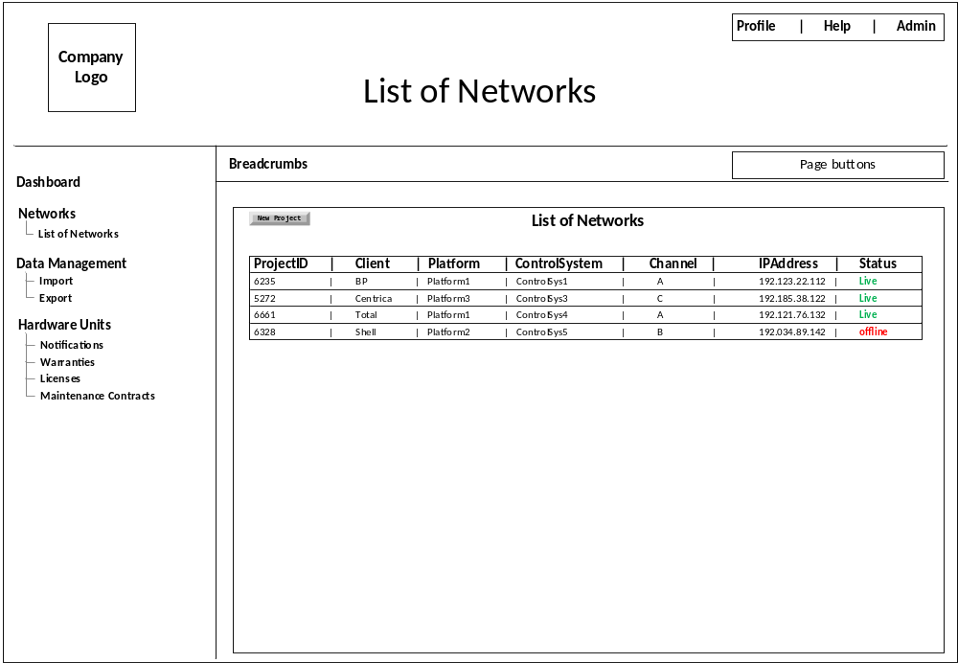
Figure 5: Page – 3, wireframe, list of networks

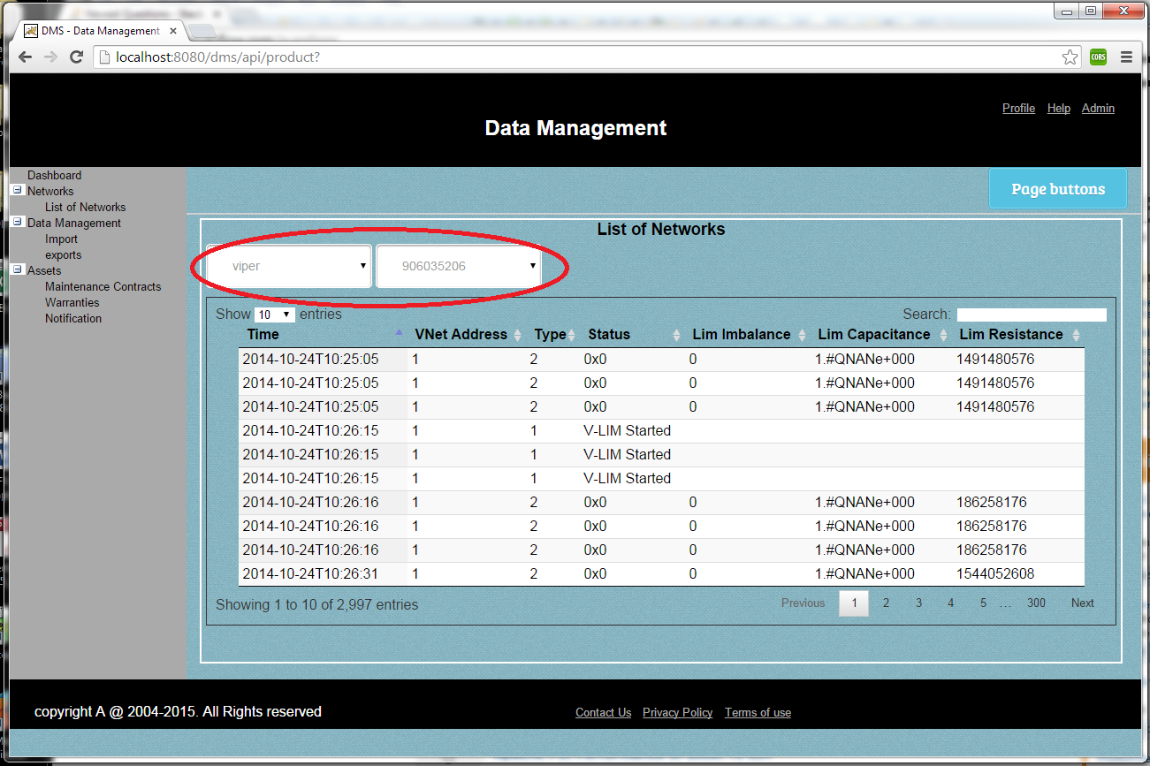
Figure 6: Page – 3 List of Networks page, actually on the browser.

List of Networks page, from the actual existing page (above), information has to be split into two pages 1. List of Networks and 2. Network Image;
Information shown in “List of Networks” are;
- Client name (Already is shown in the page, marked in red circle)
- ProjectID
- Platform
- ControlSystem
- Channel
- IP Address
- Status
These information are fetched from the database to display it on the page and provides hyperlink on each project will lead to “Network Image” page.
Status column is updated based on the connection with the unit, if the connection established shows ‘live’ (green) or ‘offline’ (red)
Information shown on the table in this page, shouldn’t be editable.
‘New Project’ button will take it to the new create page, where the new project are created.

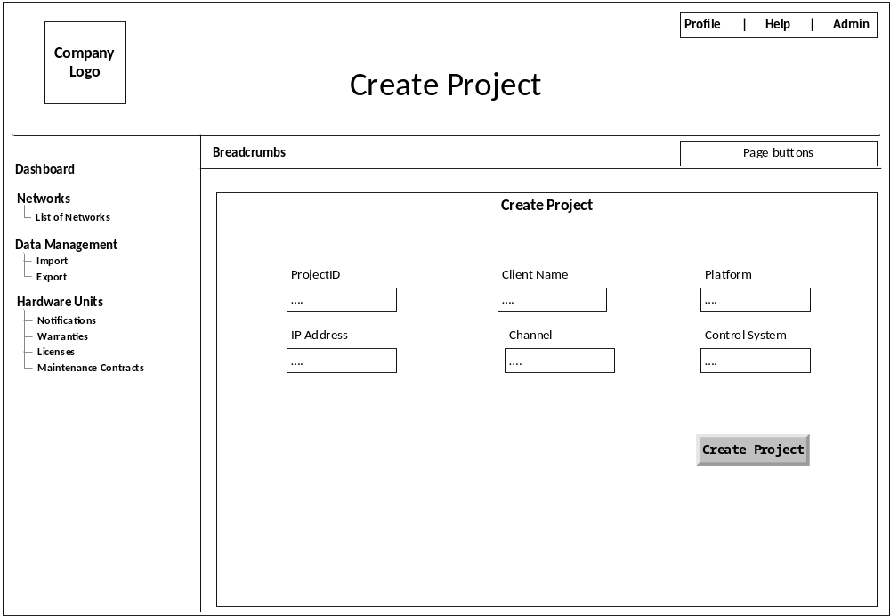
Figure 7: New Page-6, to create project

This page is used for create project, all the key project information are recorded in this page, these key information are used to identify the projects.

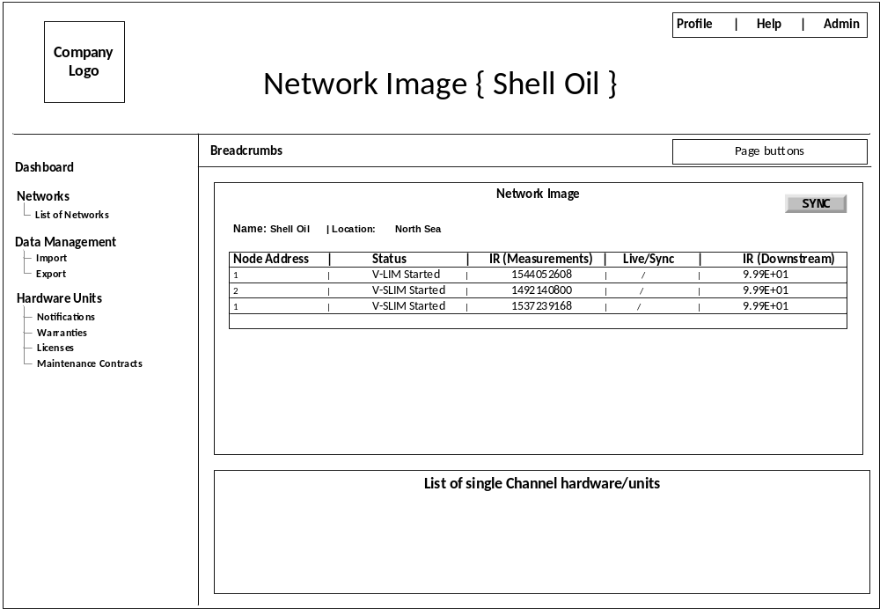
Figure 8: Page – 4, wireframe, list of network Image
This “Network Image” page will be shown after the project is chosen from the “List of Networks” page.
IR (Measurements): same as ‘Lim Resistance’;
Don’t have to show the entire record sets rather display only the last recorded data from the database.
Node Address, Status, IR(Downstream) same as ‘Lim Capacitance’;
Only last recorded data of all are shown from the database.
Live/Sync;
If the data is shown up-to now then display ‘Yes’ or ‘No’, to show the status, so that engineer can go for “Sync” option to have up-to-date record set.

Figure 9: Page – 4, actual, list of Network Image (company)

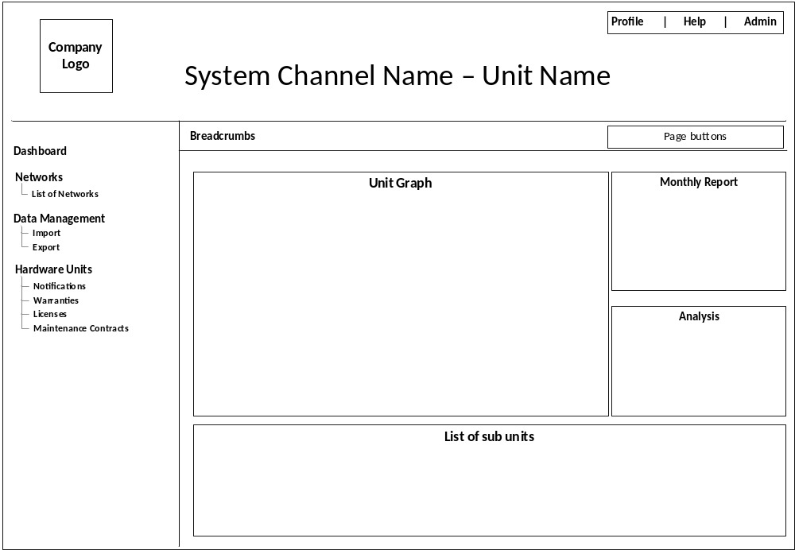
Figure 10: Page – 5, Wireframe Plotting IR graph

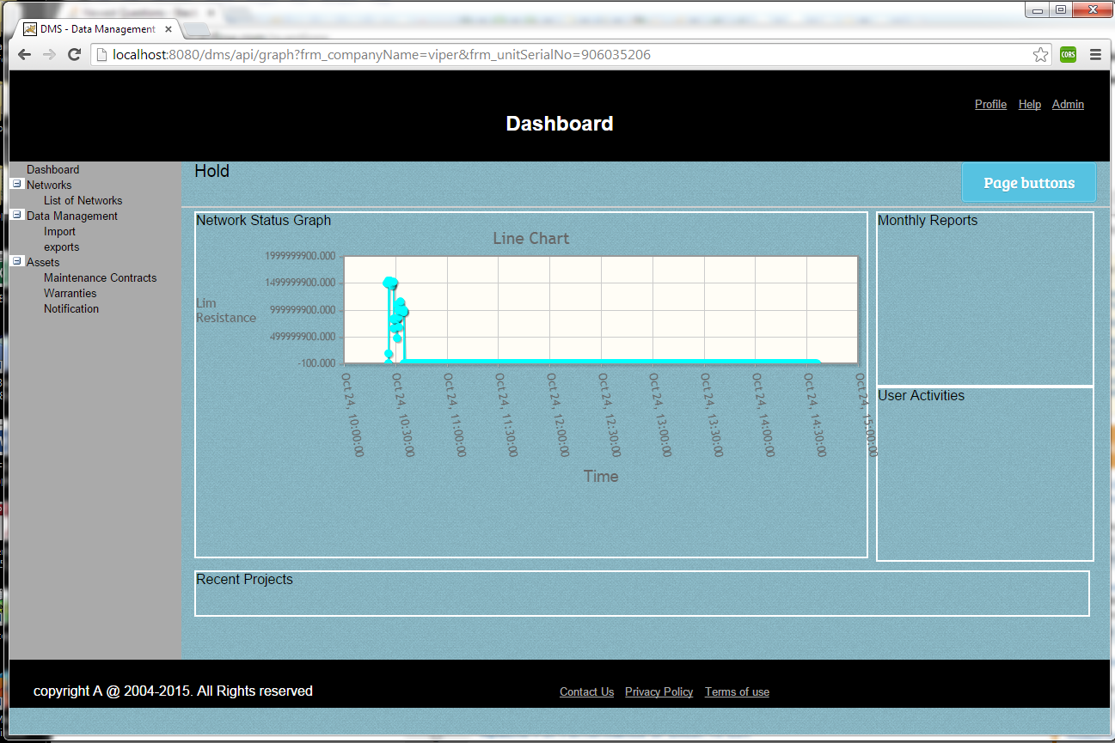
Figure 11: Page – 5, Actual IR graph on the browser.

This graph page will remain as it is.

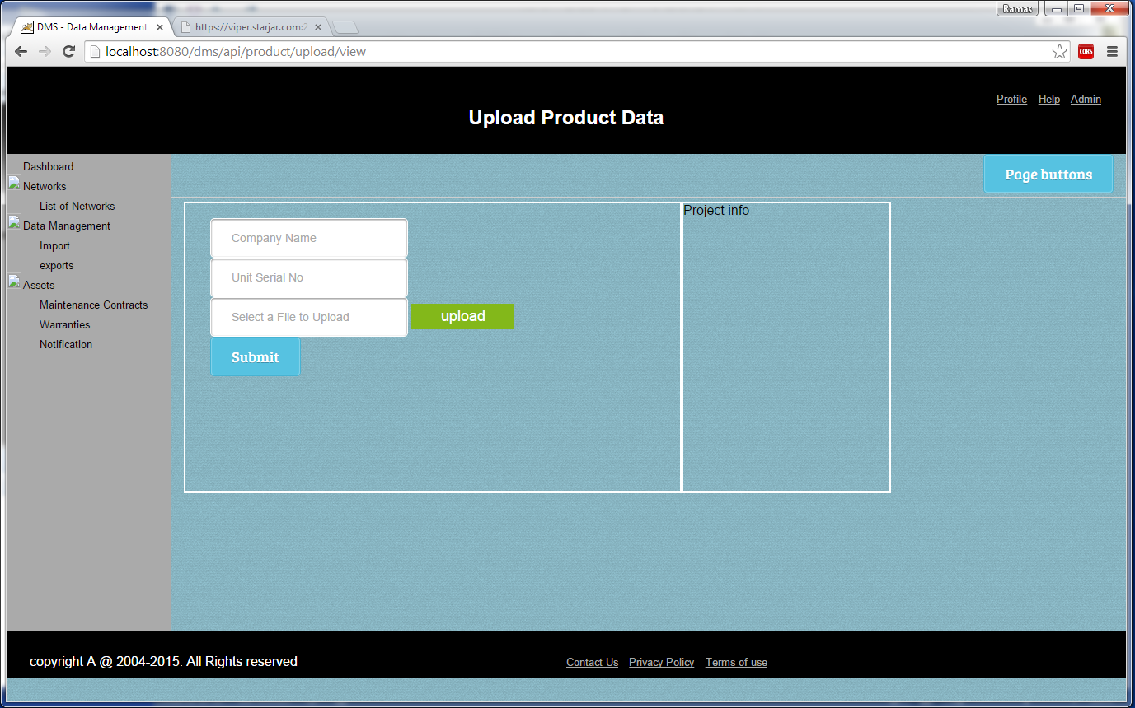
Figure 12: Page – 7, Actual CSV upload

This CSV upload page will have unedited fields for company (client) name, Unit serial no., and project name but dropdown list option to select the existing project name, company (client) name and unit serial no. from the database, to avoid the typos and duplication of the project name, serial no. and company (client) name.

Other functionalities:
- Scheduler will be introduced at the back-end and this is been scheduled at mid-night to connect and talk to all the unit(s) to get data and store it in the database.
- If the connection failure status will be updated in the new table (connect_status) at database. User could try to Sync with the unit in the “Network Image” page to get the latest update.

Database Tables:
- user
- permission
- product_data
- product_info
- project_info
- connection_status

user:
user table shall have username and password.

permission:
permission table shall have access permissions.

product_data:
product_data table shall have data logs from the unit.

product_info:
product_info table shall have unit config details from the unit.

project_info:
project_info table shall have the details are recorded from the “create project” page.

connection_status:
connection_status shall have scheduler consequences details.

